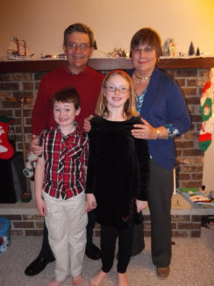

**Larry and Joy (Wolfe) Johnson & Jack and Alya Cross**

**Photo about December 2013**



**Laura (Johnson) Cross & Chris Cross**